ContactManagement_Verify Contact notes _Instance44_12-Jul-2018_03-37-56_AM_MouseClickActiononStaleElement.png



ContactManagement_Verify Contact notes _Instance44_12-Jul-2018_03-38-15_AM_SingleSignOn.png

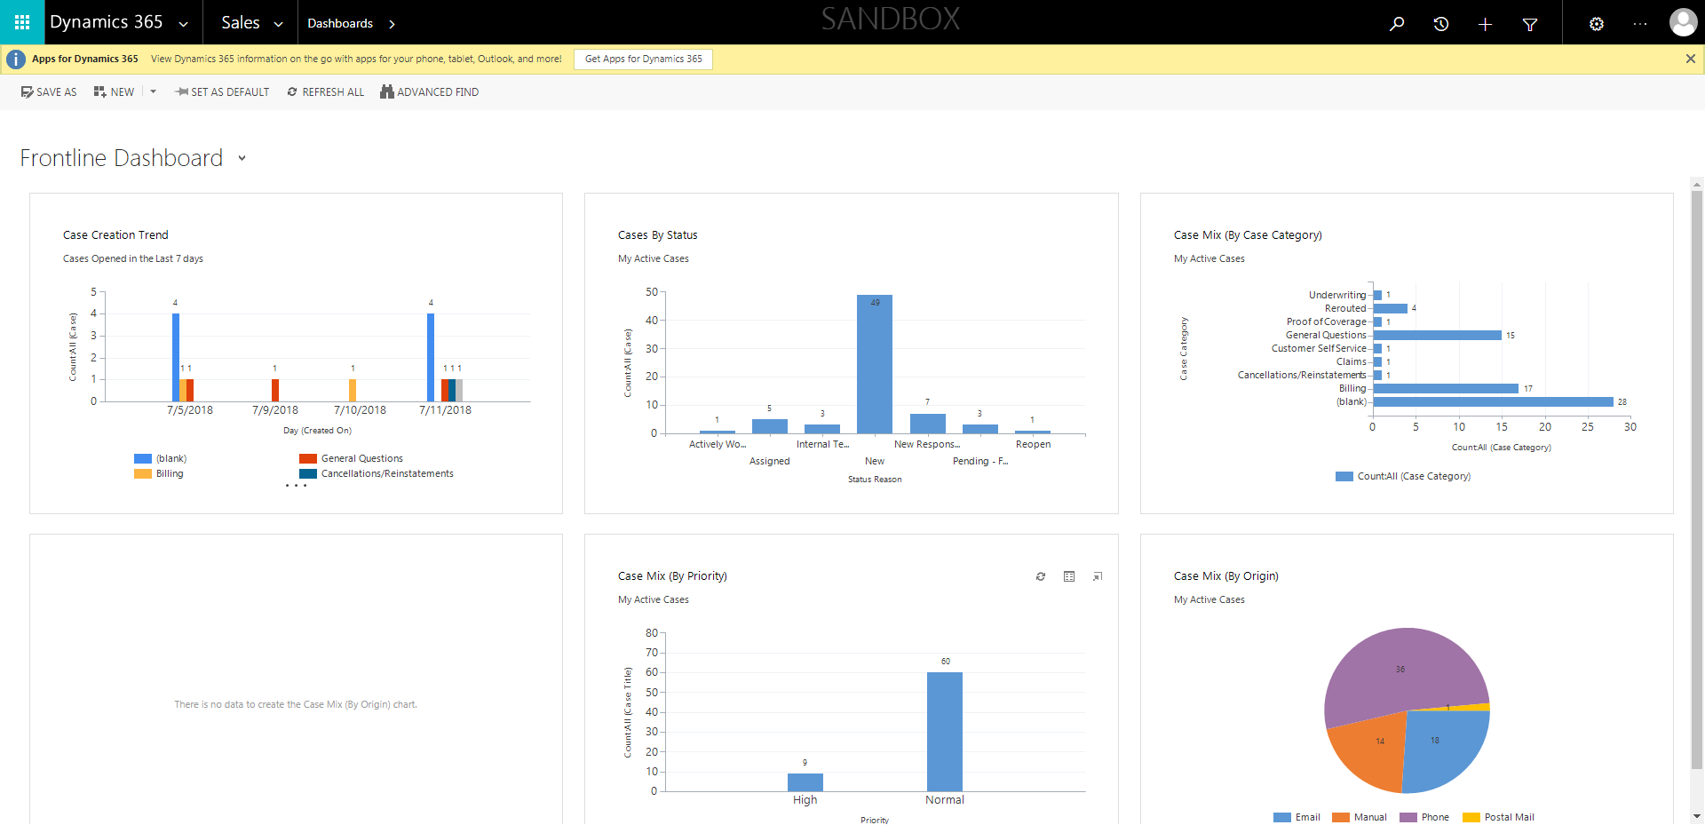

ContactManagement_Verify Contact notes _Instance44_12-Jul-2018_03-37-59_AM_MouseClickActiononStaleElement.png

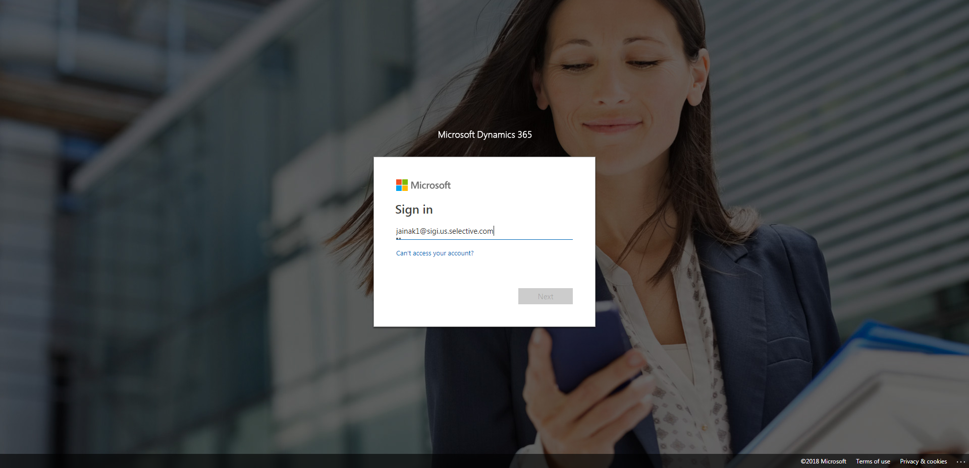

ContactManagement_Verify Contact notes _Instance44_12-Jul-2018_03-39-20_AM_Validatingcontactentitynavigation.png

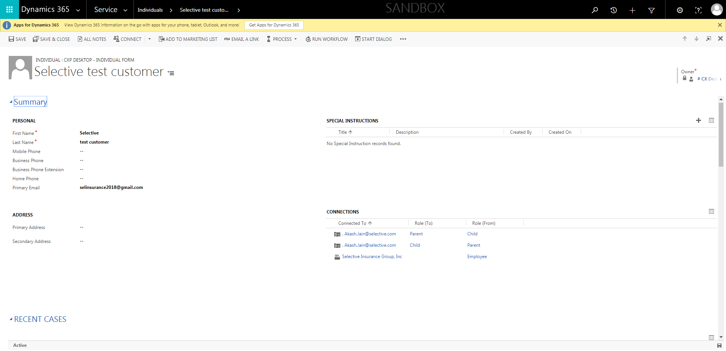

ContactManagement_Verify Contact notes _Instance44_12-Jul-2018_03-38-11_AM_SingleSignOn.png

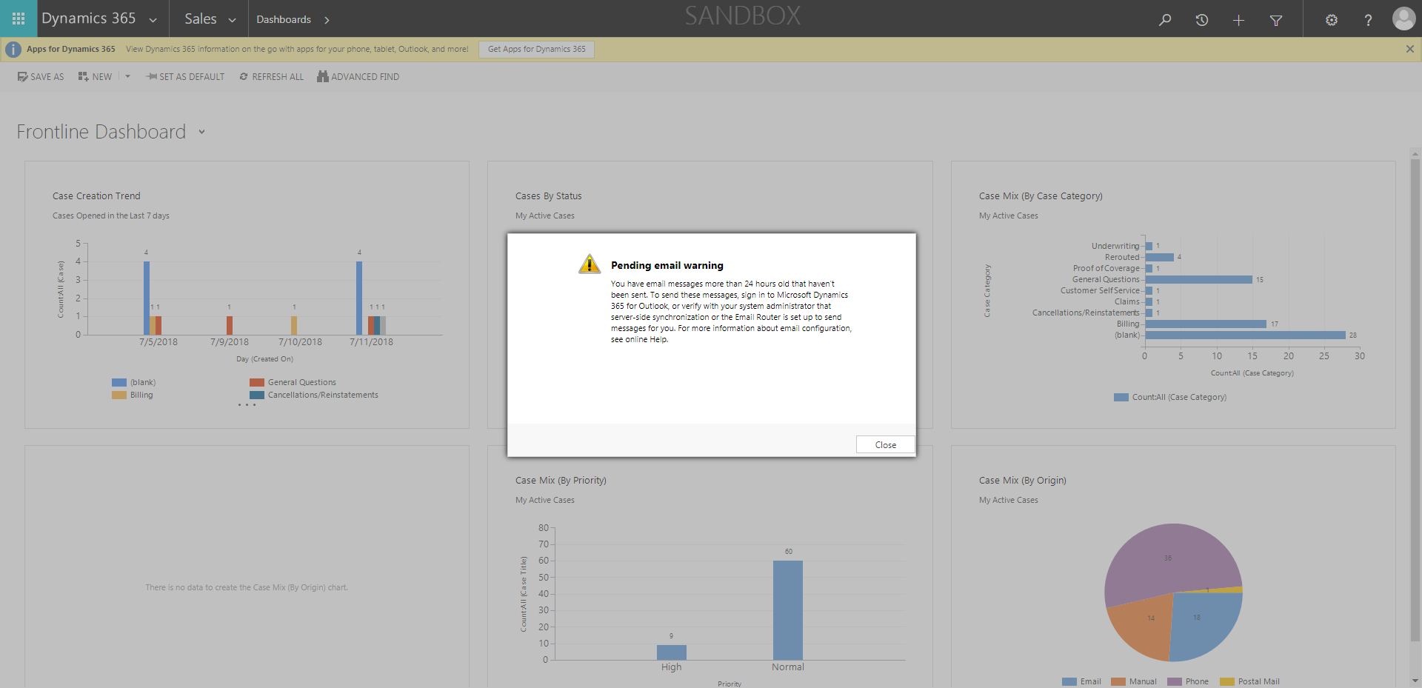

ContactManagement_Verify Contact notes _Instance44_12-Jul-2018_03-39-25_AM_VerifyingAllNotesofanindividual.png

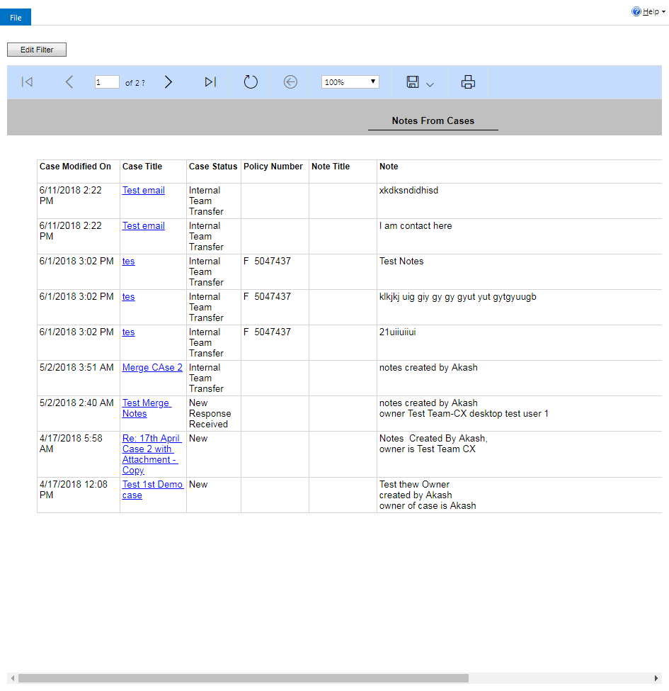

ContactManagement_Verify Contact notes _Instance44_12-Jul-2018_03-37-58_AM_EnterTextAction.png

